BS CYBER SECURITY PROGRAM, DEPARTMENT OF COMPUTER SCIENCE. HITEC UNIVERSITY TAXILLA.

***SYED ALI AHMED HASHMI***

***REG NO : 24-CyS-058***

***DEPARTMENT : CYBER SECURITY***

***SEC : A***

***COURSE : ARTIFICIAL INTELLIGENCE LAB***

***SUBMITTED TO : SIR MUBASHIR IQBAL***

***LAB REPORT :01***

Q 1: Write a Python Code to write the table of a number given by the user?

***CODE:***

num = int(input("Enter a number to print its table: "))

print(f"\nMultiplication Table of {num}:\n")

for i in range(1, 11):

    print(f"{num} x {i} = {num * i}")

***OUTPUT:***

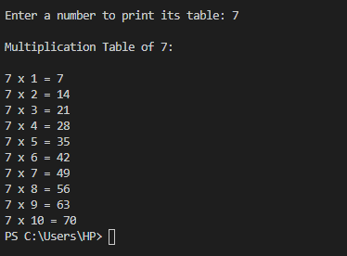

Q 2: Write a python code to check wheather a number is prime or not?

***CODE:***

num = int(input("Enter a number: "))

if num > 1:

    for i in range(2, int(num**0.5) + 1):

        if num % i == 0:

            print(f"{num} is not a prime number.")

            break

    else:

        print(f"{num} is a prime number.")

else:

    print(f"{num} is not a prime number.")

***OUTPUT:***

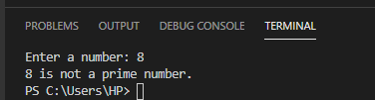

Q 3 : Write a Python program that prints numbers from 1 to 10 using a while loop. Modify the while loop to print only even numbers between 1 and 20?

***CODE:***

print("Numbers from 1 to 10:")

i = 1

while i <= 10:

    print(i)

    i += 1

print("\nEven numbers between 1 and 20:")

i = 2

while i <= 20:

    print(i)

    i += 2

***OUTPUT:***

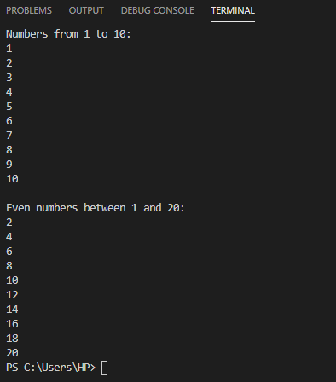

Q 4 :Write a Python program to determine whether the given number is a Harshad Number. If a number is divisible by the sum of its digits, then it will be known as a Harshad Number?

***CODE:***

num = int(input("Enter a number: "))

sum_of_digits = 0

temp = num

while temp > 0:

    digit = temp % 10

    sum_of_digits += digit

    temp //= 10

if num % sum_of_digits == 0:

    print(f"{num} is a Harshad Number.")

else:

    print(f"{num} is not a Harshad Number."

***OUTPUT:***

